Chicken, chorizo and cauliflower tray bake

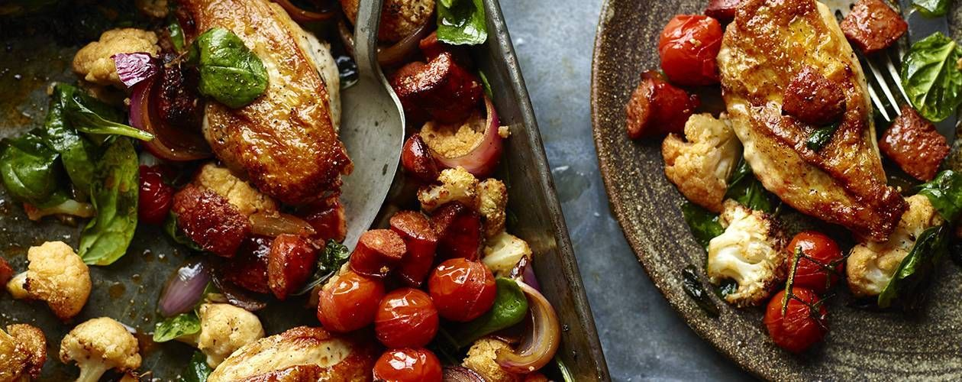
Recipe adapted from Asdagoodliving.co.uk
Try this healthy, easy chicken traybake. You can swap in/out things you prefer. It will provide you with all your 5 a day. It is a complete meal as the butternut squash / sweet potato provides the carbohydrate. All of the vegetables: cauliflower, squash, onion can be brought frozen and ready chopped. Most supermarkets sell Chorizo in ready chopped packets too, so it’s really a case of getting everything on a tray!
Serves 2 people

Ingredients
- 1tbsp olive oil
- 2 chicken breasts
- 250g fresh or frozen chopped butternut squash or sweet potato
- 250g fresh or frozen cauliflower florets
- 1 red onion, cut into wedges
- 75g cooking chorizo, cut into 1cm pieces
- (Chorizo is high in fat, but adds a lot of flavour. If you are watching your weight, substitute with garlic and a few rashers of back bacon)
- 2 sprigs thyme (or dried herbs)
- 10 cherry tomatoes
- 1 large handful baby spinach

Method
Preheat your oven to 180C/170C Fan/Gas 5.
Pour the oil in the tray and lay the chicken in it, Add the cauliflower florets and butternut squash, the red onion, chorizo and sprigs of thyme / dried mixed herbs and put the tray into the oven to roast for 25 mins.
After 25 minutes give everything a mix and place the tomatoes on top. Give the tray one more blast in the oven for 10 mins.
Remove the tray from the oven and, while it is hot, drop the spinach on top and carefully stir it through so it wilts a little in the heat. Serve.

