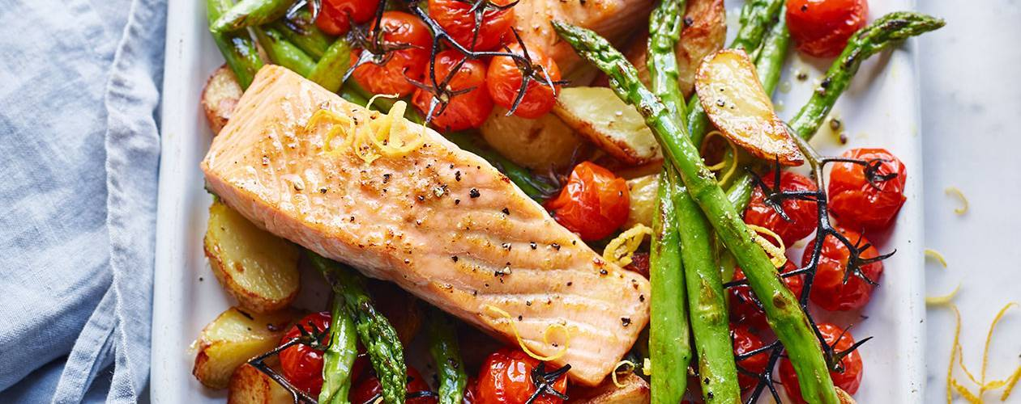

One pot Salmon and Asparagus bake

Now is the time to give this salmon and asparagus bake a go as we are right in the middle of asparagus season and so you can easily get hold of fresh, delicious English asparagus. This meal is packed with healthy nutrients, protein and antioxidants.
Serves 2

Ingredients

- 2tbs olive oil or rapeseed oil (reduce this to one tablespoon if you are trying to lose weight)
- 8 baby potatoes
- 2 fillets of salmon
- Bunch of Asparagus
- Handful of cherry tomatoes
- 1 lemon (half for juice, half for slices) (or two tablespoons of ready squeezed supermarket lemon juice)
- 1 tsp honey
- 1 large Sprig of rosemary (or 2 teaspoon of dried rosemary)
- 1 clove crushed garlic (or a squidge of ‘lazy garlic’)
- A handful of chopped parsley
- Any other veg that you would like to add such as broccoli florets, kale, peppers

Method
- Pre heat the oven to 180 degrees/ gas 5. Get out an oven proof dish and a small bowl.
- In the oven proof dish put 1 tbs oil, half of the chopped rosemary, salt and pepper. Put the potatoes in and coat with the oil. Put into the over for 25 minutes.
- Meanwhile, in the bowl, add another 1tbs oil, lemon juice, honey, rosemary, garlic salt and pepper and put aside.
- After 25 minutes carefully remove the potatoes from the oven, push to one side of the dish. Add the salmon, asparagus, tomatoes and any other veg you are using.
- Lay the lemon slices over the salmon, drizzle the liquid over the salmon and asparagus, and bake for another 20 minutes.
- After 20 minutes remove from the oven, sprinkle with parsley and serve

